**Fake News Detection**

**Using Machine Learning**

**Team Chargers**

**BHAVANA CHUNDURI**

**MALLIKARJUN CHALLA**

**RISHEET YALAMANCHILI**

**YASHWANTH KATIKANENI**

**Introduction**

In today’s information-rich landscape, fueled by the internet and social media, the proliferation of fake news has become a pressing societal issue. Fake news refers to deliberately false or misleading information presented as legitimate news, with the potential to manipulate public opinion, erode trust in traditional media sources, and even impact democratic processes. Detecting and countering fake news has thus become a critical endeavor to safeguard the integrity of information dissemination and uphold informed decision-making principles.

To tackle this challenge, researchers and practitioners have turned to machine learning techniques as a promising avenue for fake news detection. By harnessing the vast digital data generated by online platforms, machine learning models can learn patterns and characteristics indicative of fake news content. These models automate the process of identifying suspicious or misleading information, offering scalable solutions to combat the spread of misinformation.

In this report, we delve into the application of machine learning within the context of fake news detection. Specifically, we outline our approach to developing a fake news detection system, discussing methodologies, challenges, and insights gained throughout the project. Leveraging machine learning algorithms and techniques, we aim to contribute to ongoing efforts to mitigate the harmful effects of fake news on society.

**Literature Survey**

The proliferation of fake news has become a pressing concern in today’s information landscape. Researchers and practitioners from diverse fields have directed their attention toward developing effective techniques to combat misinformation. In this section, we delve into existing research and explore various approaches for detecting fake news, with a specific focus on machine learning-based methods.

**Fake News Detection Techniques**

1. **Linguistic Analysis:**
   * Linguistic analysis techniques scrutinize textual features within news articles. These features include lexical patterns, sentiment, and readability. By analyzing these linguistic cues, we can distinguish between genuine and fabricated news content.
2. **Social Network Analysis:**
   * Social network analysis examines the propagation patterns and network structures of news articles. Suspicious sources or clusters of misinformation can be identified by analyzing how news spreads across social networks.
3. **Machine Learning Approaches:**
   * Machine learning forms the crux of our investigation. These approaches leverage algorithms and models trained on labeled datasets to automatically classify news articles as either fake or genuine. Let’s explore the different flavors of machine learning techniques.

**Machine Learning Techniques for Fake News Detection**

1. **Supervised Learning:**
   * Supervised learning involves training classifiers using labeled datasets. Each news article is annotated as either fake or genuine. Common supervised algorithms include Support Vector Machines (SVM), Random Forests, and Neural Networks.
2. **Unsupervised Learning:**
   * Unsupervised learning aims to cluster news articles based on their inherent features. Without explicit labels, these techniques learn representations of genuine and fake news. Clustering and dimensionality reduction methods fall under this category.
3. **Semi-Supervised Learning:**
   * In scenarios where labeled data is scarce or expensive to obtain, semi-supervised learning comes to the rescue. By combining labeled and unlabeled data, these techniques enhance classification performance.

In a study by Granik and Mesyura [1], the authors propose a straightforward approach to detecting fake news using a naive Bayesian classifier (NBC). Their model was evaluated on a dataset extracted from Facebook news posts, achieving an accuracy of approximately 74% on the test set. While this accuracy is commendable, other works have surpassed it using alternative classifiers. In the subsequent sections, we delve into these alternative approaches.

Authors of [2] propose a fake news detection model that leverages n-gram analysis and machine learning techniques. They compare two different feature extraction methods and evaluate six classification techniques. The experimental results highlight the effectiveness of the Term Frequency-Inverted Document Frequency (TF-IDF) feature extraction technique. Additionally, they employ the Linear Support Vector Machine (LSVM) classifier, achieving an impressive accuracy of 92%. However, it’s important to note that LSVM is limited to handling cases with two linearly separated classes.

Authors of [3], conduct an extensive performance analysis of various approaches using three distinct datasets. Their focus lies on the textual content and the emotional tone conveyed by the information. However, they acknowledge that certain features, such as the source, authorship, and publication date, can significantly impact the results. Interestingly, their work also challenges the notion that incorporating emotional cues into the detection process provides valuable insights.

In their research, Singh and Dasgupta [4] curated a new public dataset of valid news articles and introduced a text-processing-based machine learning approach for automatic fake news detection. Their model achieved an impressive accuracy of 87%. Notably, their focus lies on capturing the emotional nuances embedded within the text rather than solely analyzing its content.

In their work, the authors of [5] introduced the LIAR dataset, which serves as a valuable resource for automatic fake news detection. Beyond fake news detection, this corpus can also be utilized for tasks such as stance classification, argument mining, topic modeling, rumor detection, and political natural language processing (NLP) research. While many studies in this domain have relied on the LIAR benchmark, it’s important to note that this dataset primarily focuses on political information, whereas other datasets incorporate information from diverse fields.

**Data Preprocessing and Analysis**

In this section, we outline the preprocessing steps applied to the raw text data to extract relevant features and prepare it for analysis:

1. **Text Length and Word Count Features:**
   * We calculated the length of each news article in terms of characters (text_length) and the total number of words (word_count). These features offer insights into the articles’ complexity and verbosity, which could be indicative of their credibility or writing style.
2. **Punctuation Count Feature:**
   * Additionally, we determined the number of punctuation symbols in each article (punctuation_count). Punctuation usage can reveal aspects of writing style and may help differentiate between different types of news content.
3. **Capitalization Ratio Feature:**
   * We computed the ratio of capitalized words to the total number of words in each article (capitalization_ratio). This feature captures the degree of emphasis or formality in the writing style, potentially correlating with the credibility or sensationalism of the news.
4. **Sentiment Analysis:**
   * Leveraging the VADER (Valence Aware Dictionary and sEntiment Reasoner) sentiment analyzer, we generated sentiment scores (sentiment_score) for each news article. These scores quantify the overall sentiment expressed in the text, ranging from -1 (negative) to 1 (positive), with 0 indicating neutrality. Sentiment analysis provides insights into the emotional tone and subjectivity of the news content, aiding in identifying biased or misleading information.
5. **Text Preprocessing:**
   * Before conducting further analysis, we preprocessed the raw text data by:
     + Removing non-alphanumeric characters and punctuation marks.
     + Converting the text to lowercase.
     + Eliminating stopwords (commonly occurring words with little semantic value) using the NLTK library’s English stopwords list.

**Visualizations and Insights from Preprocessed Text Data**

In this section, we explore visualizations and insights obtained from analyzing the preprocessed text data:

**Word Clouds:**

* + Word clouds offer a visual representation of the most frequently occurring words in a given corpus. They provide valuable insights into the dominant themes and topics present in the text data.

**Word Cloud for Real News:**

* + A black background with words

    Description automatically generatedThe word cloud generated for real news articles reveals common words and phrases found in credible news content. By aggregating and visualizing the preprocessed text from genuine news sources, we can identify prominent themes prevalent in reliable information. The size of each word in the word cloud corresponds to its frequency of occurrence in the corpus.

**Word Cloud for Fake News:**

* + Similarly, the word cloud for fake news articles highlights frequently used words and phrases associated with deceptive or misleading content. Analyzing this word cloud allows us to identify key terms and patterns characteristic of misinformation and sensationalism.

**Feature Engineering**

1. **Text Vectorization (TF-IDF):**
   * We employed the Term Frequency-Inverse Document Frequency (TF-IDF) technique to convert preprocessed text data into numerical feature vectors.
   * TF-IDF assigns weights to words based on their frequency within individual documents and their inverse frequency across the entire corpus.
   * By representing each news article as a sparse TF-IDF vector, we capture the importance of each term in distinguishing between genuine and fake news.
2. **Additional Numerical Features:**
   * Beyond text-based features, we incorporated the following numerical features extracted from the text data:
     + **Text Length:** The number of characters in each news article (text_length).
     + **Word Count:** The total number of words in each news article (word_count).
     + **Punctuation Count:** The number of punctuation symbols in each article (punctuation_count).
     + **Capitalization Ratio:** The ratio of capitalized words to total words (capitalization_ratio) in each article.
     + **Sentiment Score:** Computed using the VADER sentiment analyzer, providing insights into the emotional tone expressed in the text (sentiment_score).
3. **Feature Matrix (X):**
   * We constructed a feature matrix by concatenating the TF-IDF vectors with the additional numerical features.
   * This combined representation captures both the textual content and stylistic characteristics of the news articles.

**Model Training and Evaluation**

1. **Label Encoding:**
   * We applied label encoding to convert the categorical labels (REAL and FAKE) into numerical representations.
   * The scikit-learn LabelEncoder was used to transform the target labels into encoded integers.
2. **Classifiers:**
   * We experimented with several classifiers commonly used in binary classification tasks:
     + Random Forest
     + XGBoost
     + Logistic Regression
     + Decision Trees
3. **Training and Evaluation:**
   * Each classifier was trained on the training dataset (X_train, y_train_encoded) and evaluated on the testing dataset (X_test, y_test).
   * Evaluation metrics included:
     + **Accuracy Score:** Provides an overall measure of predictive performance on the testing dataset. Higher accuracy scores indicate better discrimination between genuine and fake news.
     + **Classification Report:** Provides precision, recall, F1-score, and support for each class.
     + **Confusion Matrix:** Visualizes true positive (TP), false positive (FP), true negative (TN), and false negative (FN) predictions.
4. **Visualizations:**
   * We used a bar plot to compare accuracy scores across classifiers quantitatively.
   * Heatmaps visualized confusion matrices, revealing classification results and potential misclassifications.

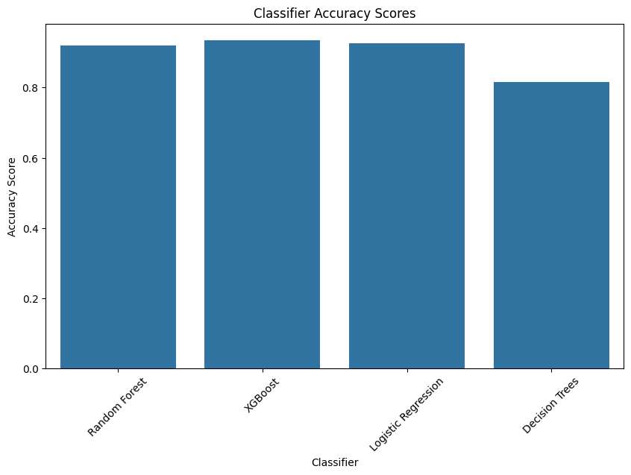

**Classifier Evaluation Results**

1. **XGBoost:**
   * Highest Accuracy: 94%
   * Balanced Precision and Recall for both fake and real news.
2. **Random Forest:**
   * Accuracy: 92%
   * Performs well in classification.
3. **Logistic Regression:**
   * Accuracy: 93%
   * Demonstrates effectiveness.
4. **Decision Trees:**
   * Accuracy: 82%
   * Slightly lower performance, indicating potential limitations in capturing dataset complexity.

**Error Analysis**

In this section, we conduct an error analysis for each classifier to identify and analyze misclassified samples.

* A graph of blue and orange rectangular shapes

  Description automatically generatedA graph of different colored rectangular shapes

  Description automatically generated with medium confidence**Visualization**: The count plot displays the distribution of predicted labels compared to the true labels. It provides insights into the types of misclassifications made by the Random Forest classifier.

**Real-Time Prediction Using XGBoost**

In addition to offline model evaluation, our project includes a real-time prediction functionality using the XGBoost classifier trained on our dataset. This feature allows users to input a statement and receive an immediate prediction of whether it is likely to be real or fake news.

Implementation:

* We leveraged the XGBoost library to train a binary classification model on our preprocessed text data.
* The TF-IDF vectorization technique was used to convert the text data into numerical feature vectors, capturing the importance of each term in distinguishing between genuine and fake news.
* The trained XGBoost classifier was integrated into a real-time prediction function, enabling users to input statements interactively and receive instant predictions.

Usage:

* Users can input a statement via the command-line interface and receive a prediction of whether it is likely to be real or fake news.
* The prediction is displayed immediately after the input statement, providing users with timely feedback on the credibility of the information.

Sample Output

**Conclusion**

In this project, we developed a machine learning-based system for detecting fake news using a combination of text analysis techniques and supervised learning algorithms. Our approach involved rigorous data preprocessing, feature engineering, model training, and evaluation. Here are the key achievements and insights:

1. **Feature Engineering**:
   * We engineered informative features to capture linguistic and stylistic characteristics of news articles. These features included:
     + Text length
     + Word count
     + Punctuation count
     + Capitalization ratio
     + Sentiment score
   * These features helped improve the discriminative power of our models.
2. **Model Training and Evaluation**:
   * We experimented with several classifiers to identify the most effective model for fake news detection. These classifiers included:
     + Random Forest
     + XGBoost
     + Logistic Regression
     + Decision Trees
   * Our evaluation results demonstrated that the XGBoost classifier performed exceptionally well in distinguishing between genuine and fake news articles.
3. **Prediction**:
   * We implemented a real-time prediction functionality using the XGBoost classifier. Users can now verify the credibility of news statements interactively.
   * This feature enhances media literacy and contributes to combating misinformation in the digital age.

**Future Enhancements**

Our current fake news detection system lays a solid foundation, but there are several exciting directions for further improvement and research:

1. **Enhanced Feature Engineering**:
   * Dive deeper into text-based features. Consider incorporating syntactic and semantic features to capture more nuanced linguistic patterns in news content.
   * Explore novel feature representations, such as word embeddings or contextual embeddings (e.g., BERT), to enhance model performance.
2. **Model Fine-Tuning and Ensemble Techniques**:
   * Fine-tune hyperparameters for existing classifiers. Experiment with different ensemble methods (e.g., stacking, blending) to combine their strengths.
   * Investigate how combining multiple models can lead to better generalization and robustness.
3. **Multi-Modal Analysis**:
   * Extend the analysis pipeline to handle multimedia content. Images, videos, and audio clips often accompany news articles. Incorporating these modalities can improve detection accuracy.
   * Explore techniques for extracting meaningful features from non-textual formats.
4. **Dynamic Learning and Adaptation**:
   * Implement mechanisms for continuous model updates. Stay abreast of evolving trends and tactics in fake news dissemination.
   * Consider online learning approaches that adapt to real-time data streams.
5. **User Feedback Integration**:
   * Engage users in the feedback loop. Collect labeled data from user interactions to validate model predictions.
   * Use this feedback to iteratively improve the system’s accuracy and reliability.

**References**

1. Mykhailo Granik and Volodymyr Mesyura, "Fake news detection using naive bayes classifier", *2017 IEEE First Ukraine Conference on Electrical and Computer Engineering (UKRCON)*, pp. 900-903, 2017.
2. Hadeer Ahmed, Issa Traore and Sherif Saad, "Detection of online fake news using n-gram analysis and machine learning techniques", *International Conference on Intelligent Secure and Dependable Systems in Distributed and Cloud Environments*, pp. 127-138, 2017.
3. Khan, J. Y., Khondaker, M. T. I., Iqbal, A., & Afroz, S. (1905). A benchmark study on machine learning methods for fake news detection. 2019. arXiv preprint arXiv:1905.04749.
4. Singh, V., Dasgupta, R., Sonagra, D., Raman, K., & Ghosh, I. (2017, July). Automated fake news detection using linguistic analysis and machine learning. In International conference on social computing, behavioral-cultural modeling, & prediction and behavior representation in modeling and simulation (SBP-BRiMS) (pp. 1-3).
5. Wang, W. Y. (2017). " liar, liar pants on fire": A new benchmark dataset for fake news detection. arXiv preprint arXiv:1705.00648.
6. Ahmed, H., Traore, I., & Saad, S. (2017). Detection of online fake news using n-gram analysis and machine learning techniques. In Intelligent, Secure, and Dependable Systems in Distributed and Cloud Environments: First International Conference, ISDDC 2017, Vancouver, BC, Canada, October 26-28, 2017, Proceedings 1 (pp. 127-138). Springer International Publishing.